Snowflake Excelerator Build Guide

# Purpose of this Guide

This guide is intended to help Excel/VBA developers to make changes to the Snowflake Excelerator.

# Where to get Excelerator

The Snowflake Excelerator can be found on the Snowflake-Labs GitHub page.   
<https://github.com/Snowflake-Labs/Excelerator>

The repository can be cloned to your local desktop.

# Installation

The SnowflakeExcelAddin.xlam file is the Addin that will be added to Excel. It also contains all the code to get started developing.

* Unblock file if needed  
  If the SnowflakeExcelAddin.xlam file was downloaded from the GitHub repo by itself, and not by cloning the repository, then you will need to ‘unblock’ the file so it can be used. To do this right click on the file and select ‘Properties’. On the ‘General’ tab, check the ‘Unblock’ checkbox. If this checkbox doesn’t exist, then it is not blocked.

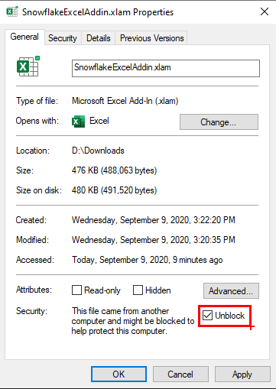

* Turn the Add-in into an Excel file
  + Open the SnowflakeExcelAddin.xlam file and select ‘Enable Macros’ when asked.
  + Open the VBA editor by clicking Alt-F11 keys.
  + Once opened, in the left-hand pane, select ‘ThisWorkbook’.

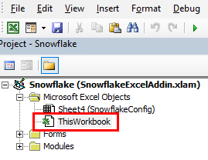

* + Click the F4 key to open the ‘Properties’ Windows, if not already open.
  + In the Properties window, scroll down until you found the ‘IsAddin’ property. Change the property from ‘True’ to ‘False’.

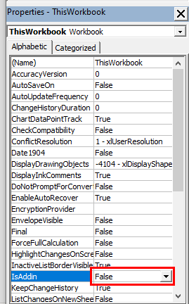

* Save the Excel workbook in you GitHub repository directory
  + Switch back to Excel by clicking on the Excel icon in the top left side of the menu.

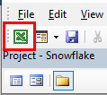

* + Click ‘Save As’ and remove the ‘.xlam’ suffix. Make sure the ‘Excel Macro-Enabled Workbook (*.xlsm)’ file type is selected.

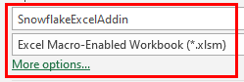

* + Choose the location to save as the root directory in your Excelerator repository. It should be at the same level as the ‘src’ directory.
* Close the workbook and reopen it.
  + Click a Security Warning the below the Ribbon appears, click the ‘Enable Content’ button.

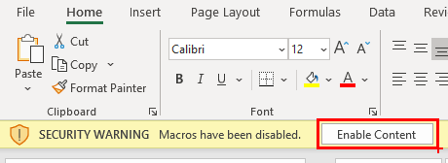

The workbook and associated VBA code is now ready to be developed with.

# Making code changes

To access the VBA code, open the above workbook and press the ‘Alt-F11’ keys. This will open the VBA editor where code changes can be made.

# Pulling the latest code

When code changes have been uploaded to the GitHub repository by other developers, you can import the new code into your Excel Workbook. This process will only work if your workbook is in the same directory as your ‘src’ directory in the repository.

## Importing the source code

* Pull the latest changes from GitHub.
* In the above Snowflake workbook, click on the ‘Add-Ins’ menu. This will only be there if you closed and re-opened the workbook as instructed above.
* Click on the ‘Import Project Code’ menu item on the left.

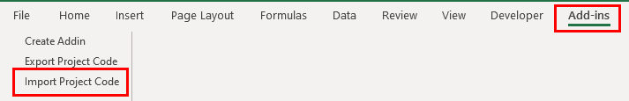

* You will see a message: ‘Finished importing code for: Snowflake’
* The latest code has now been imported into the workbook.

# Pull Requests

After adding a feature, fixing a bug or making any code change that you want to share, you can create a pull request for the Excelerator project. This process will only work if your workbook is in the same directory as your ‘src’ directory in the repository.

To do this, your code must be exported from the workbook.

## Exporting the source code

* In the Snowflake workbook, click on the ‘Add-Ins’ menu
* Click the ‘Export Project Code’ menu item.
* You will see a message: ‘Finished exporting code for: Snowflake’
* The latest code has now been exported to the ‘src’ directory.

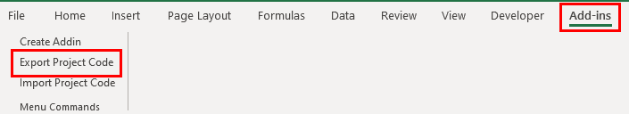

## Removing binary files that were not modified

An exported VBA userform consists of 2 files. One text file containing VBA code (.frm) and another binary file containing image information (.frx). GitHub does not inspect binary files to see if they have changed, so it marks all binaries as modified. In the case where a binary file has not changed, it would be inefficient to push it to GitHub where a new version would be created. For this reason, it would be best practice to discard any binary files that have not changed prior to committing changes to you local repository.

# Building the Add-ins

There are 2 Add-ins that are create as part of the build process.

1. SnowflakeExcelAddin.xlam - Full version allowing query and update
2. SnowflakeExcelAddinReadOnly.xlam - Read only version allowing only query

To build the Add-in, click on the Add-ins menu, then click ‘Create Addin’ on the left.

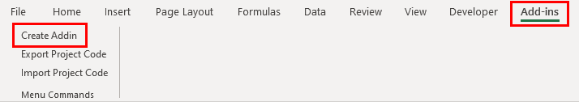

When the process is complete the 2 files will be created in the root directory of the repository. These files can then be distributed to users to read and write data to and from Snowflake.